SQL MINIPROJECT

DATA UNDERSTANDING:
Manager Requirement:
Give me overall business performance summary for the last quarter.
Questions:
- Find total number of transactions.
SQL->
Select count(sale_id) as total_transactions from sales
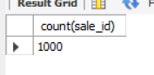

- Find total revenue generated.

SQL->
select sum(amount) as total_revenue from sales
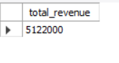

3.Find total unique customers.
SQL->

SELECT COUNT(DISTINCT customer_id) AS unique_customers
FROM sales;

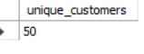

4.Find average order value.

SQL->
select avg(amount) as avg_order_val from sales

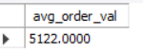

5.Find total quantity sold.
SQL->
Select sum(quantity) as Total_sold from sales
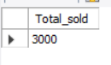

6.Find minimum and maximum sale amount.
SQL->
select min(amount) as minimum_amount,max(amount) as maximum_amount from sales
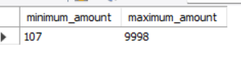

7.Find average discount given.
SQL->
Select avg(discount) as Avg_Discount from sales
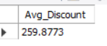

8.Find total sales per store.
SQL->
select st.store_id,st.store_name,sum(amount) from sales s join stores st on s.store_id = st.store_id group by st.store_name,st.store_id
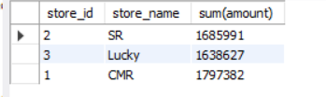

9. Find total sales per category.
SQL->
select s.product_id,p.category , sum(amount) as Total_sales from sales s join products p on s.product_id = p.product_id group by s.product_id, p.category
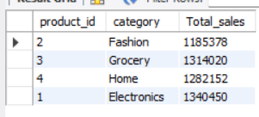

10. Find number of transactions per day.
SQL ->
select sale_date, count(sale_id) as transactions from sales group by sale_date order by sale_date

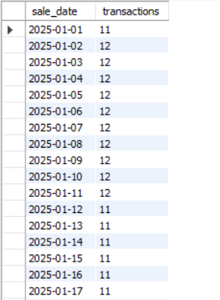

DATA CLEANING :
Manager Requirement:
Data looks inconsistent, fix NULL issues before analysis.
Questions:
11.Replace NULL discount with 0.

SQL->

SELECT NVL(discount, 0) AS discount_cleaned
FROM sales;

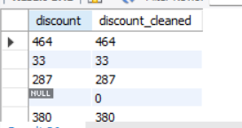

12.Find number of NULL discounts.
SQL->

SELECT COUNT(*) AS Number_of_null_discounts
FROM sales
Where discount IS NULL

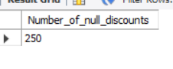
13.Calculate net revenue (amount - discount).
SQL->

SELECT amount - NVL(discount,0) AS net_revenue
FROM sales;

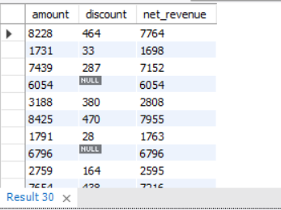

14.Replace NULL quantity with 1.

SQL->

Select NVL(quantity,1) as quantity_cleaned from sales

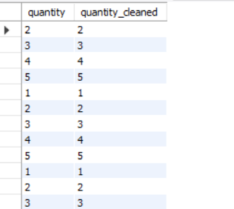

15.Identify rows where amount is NULL.

SQL->

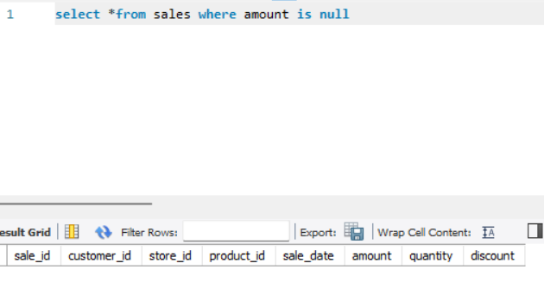
16.Use COALESCE to handle multiple NULL columns.
SQL->

Select coalesce(discount,0) as discount_fixed from sales

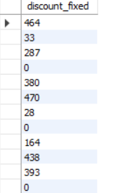

17.Create a cleaned column for revenue.

SQL->

SELECT amount,discount,(amount - COALESCE(discount, 0)) AS cleaned_revenue FROM sales;

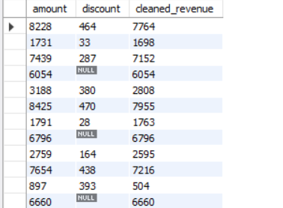

18.Check percentage of missing data.
SQL->

SELECT
COUNT(CASE WHEN discount IS NULL THEN 1 END) * 100.0 / COUNT(*)
AS pct_missing_discount
FROM sales

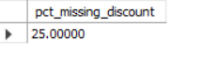
19.Flag rows with missing values.
SQL->
SELECT *,
CASE
WHEN discount IS NULL OR amount IS NULL THEN 'Missing'
ELSE 'Clean'
END AS data_status
FROM sales;

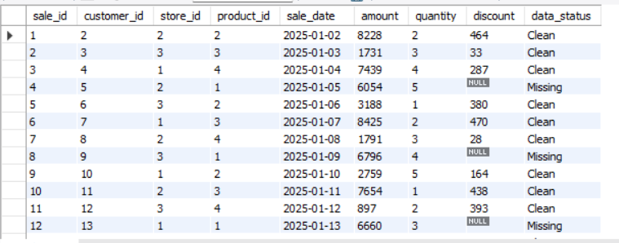

20.Preparing dataset for analysis
SQL->
CREATE OR REPLACE VIEW sales_cleaned AS
SELECT
s.sale_id,
s.customer_id,
c.customer_name,
s.store_id,
st.store_name,
s.product_id,
p.category,
s.sale_date,

-- Cleaned fields
NVL(s.amount, 0) AS amount,
NVL(s.quantity, 1) AS quantity,
NVL(s.discount, 0) AS discount,

-- Derived column
NVL(s.amount, 0) - NVL(s.discount, 0) AS net_revenue,

-- Data quality flag
CASE
WHEN s.amount IS NULL OR s.discount IS NULL THEN 'Missing'
ELSE 'Clean'
END AS data_status

FROM sales s
JOIN customers c ON s.customer_id = c.customer_id
JOIN stores st ON s.store_id = st.store_id
JOIN products p ON s.product_id = p.product_id;

Select *from sales_cleaned

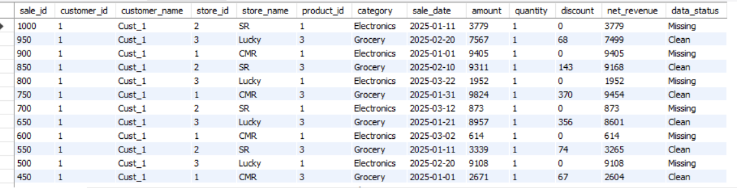

FILTERING
Manager Requirement:
I want specific insights based on conditions.
Questions:
21.Find sales in last 30 days.
SQL->

SELECT *FROM sales_cleaned WHERE sale_date >= (SELECT MAX(sale_date) FROM sales_cleaned) - INTERVAL 30 DAY;

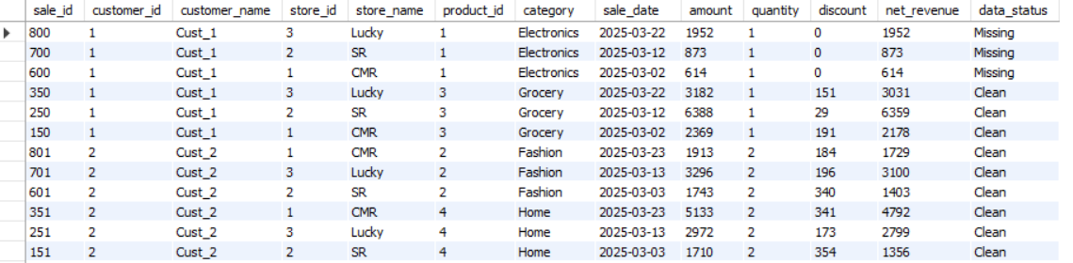

22.Find sales above 5000.
SQL->

Select *from sales_cleaned where amount >= 5000

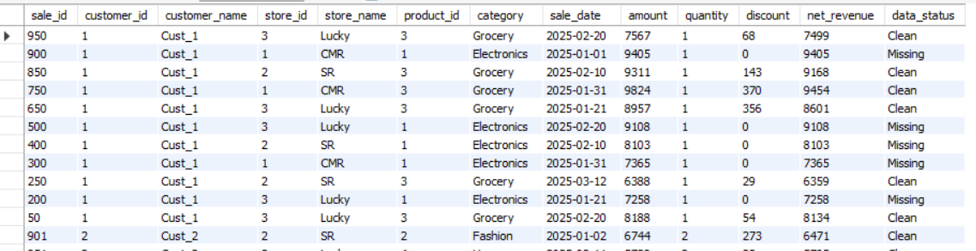

23.Find sales between 1000 and 5000.
SQL->

Select *from sales_cleaned where amount between 1000 and 5000

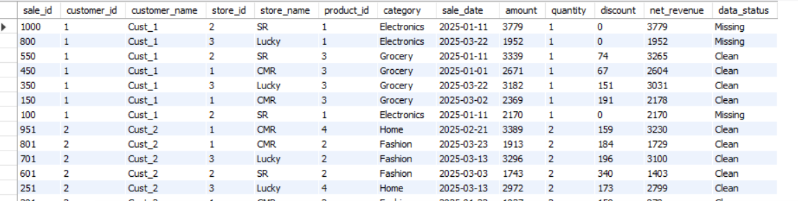

24.Find sales from CMR store.
SQL->
Select *from sales_cleaned where store_name = ‘CMR’

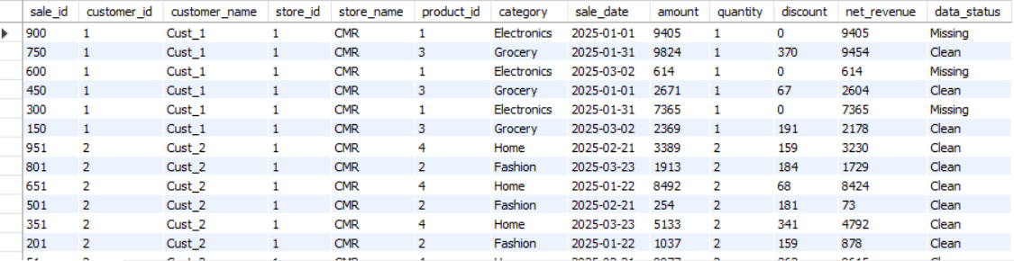

25.Find Electronics category sales.
SQL->
Select *from sales_cleaned where category = ‘Electronics’

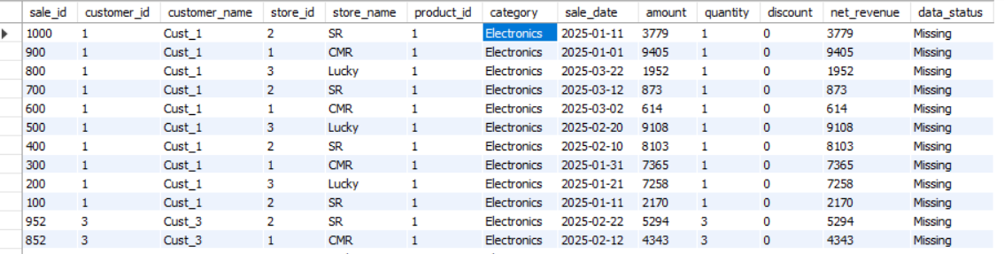

26.Find sales excluding Grocery category.
SQL->
Select *from sales_cleaned where category <> ‘Grocery’

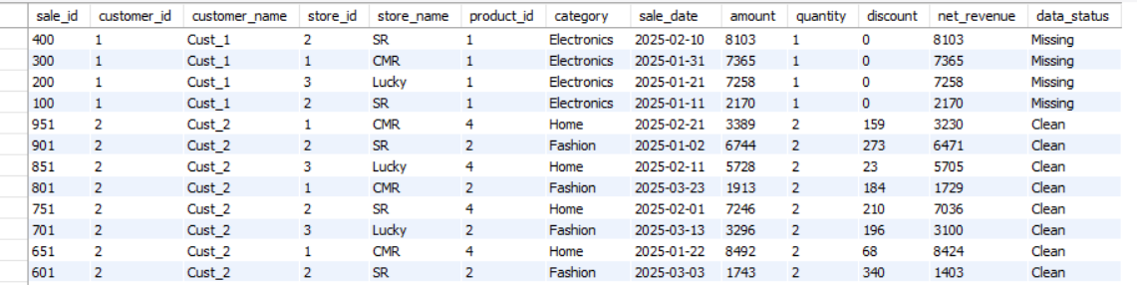

27.Find customers from specific store.
SQL->
Select store_name,count(distinct customer_id) as customers from sales_cleaned group by store_name

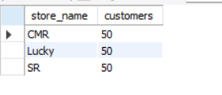
28.Find high discount transactions.
SQL->
Selct *from sales_cleaned where discount > 300

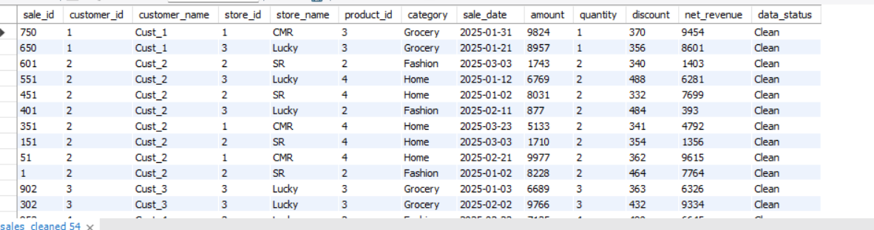

29.Find low quantity sales.
SQL->

Select *from sales_cleaned where quantity <3

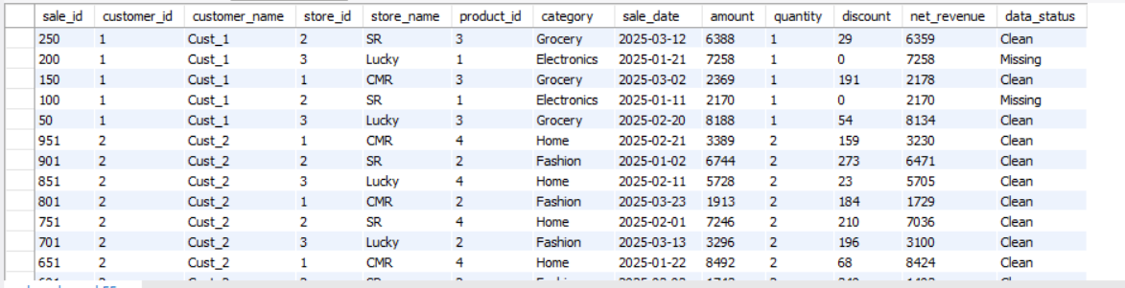

30.Find recent transactions.
SQL->Select *from sales_cleaned order by sale_date desc fetch 10 rows

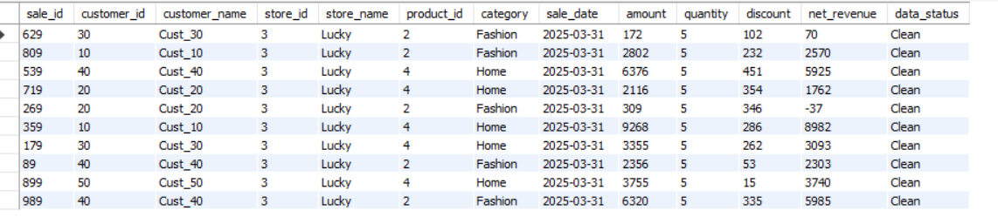
AGGREGATION : GROUP BY
Manager Requirement:
Break down performance across business segments.
Questions:
31.Revenue per store.
SQL->
Select store_name , sum(net_revenue) as revenue from sales_cleaned group by store_name
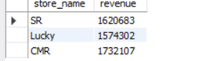

32.Revenue per category.
SQL->
select category , sum(net_revenue) as revenue from sales_cleaned group by category
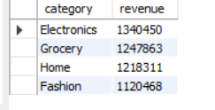

33.Revenue per customer.
SQL->
Select cutomer_id, customer_name , sum(net_revenue) as total_revenue from sales_cleaned group by customer_id, customer_name
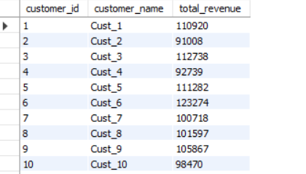

34.Monthly revenue.
SQL-> SELECT TRUNC(sale_date, 'MM') AS month, SUM(net_revenue) AS total_revenue FROM sales_cleaned GROUP BY TRUNC(sale_date, 'MM') ORDER BY month;
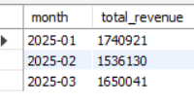

35.Daily revenue.
SQL->
Select sale_date , sum(net_revenue) as total_revenue from sales_cleaned group by sales_date, order by sales_date

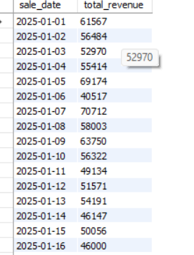

36.Average sales per store.
SQL->
Select store_name , avg(net_revenue) as avg_sales from sales_cleaned group by store_name
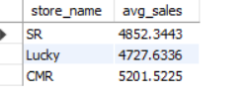

37.Total quantity per category.
SQL->
Select category sum(quantity) as total_quantity from sales_cleaned group by category

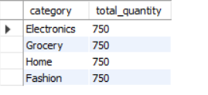

38.Total discount per store.
SQL->
Select store_name , sum(discount) as total_discount from sales_cleaned group by store_name
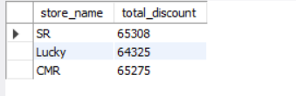

39.Customer-wise total spending.
SQL->
Select customer_id , cusyomer_name , sum(net_amount) as total spent from sales_ cleaned group by customer_id, customer_name

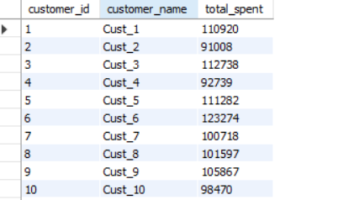

40.Store-wise transaction count.
SQL->
Select store_name , count(sale_id) as total_transactions from sales_cleaned group by store_name

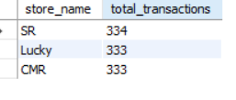
HAVING
Manager Requirement:
Find top performing segments.
Questions:

41.Customers with revenue > 20000.
SQL->
Select customer_id,customer_name,sum(net_amount) as total_revenue from sales_cleaned group by customer_id,customer_name having total_revenue>20000

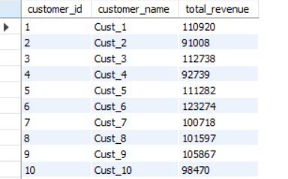

42.Stores with revenue > 100000.
SQL->
Select store_name , sum(net_amount) as total_revenue from sales_cleaned group by store_name having total_revenue > 100000

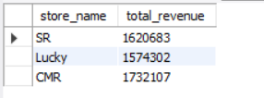

43.Categories with avg sales > 3000.
SQL->
Select category , avg(net_amount) as avg_sales from sales_cleaned group by category having avg_sales > 3000

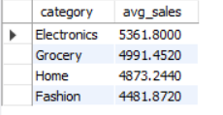

44.Customers with more than 5 transactions.
SQL->
Select customer_id, customer_name , count(sale_id) as transactions from sales_cleaned group by customer_id,customer_name having transaction>5

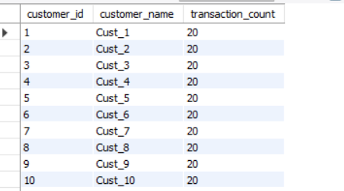

45.Stores with high discount usage.
SQL->
Select store_name, sum(discount) as total_discount from sales_cleaned group by store_name having total_discount > 20000

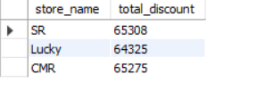

46.Categories with low performance.
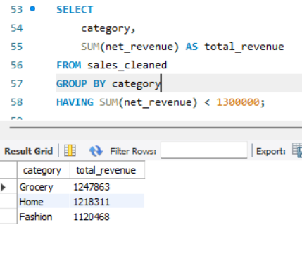
47.Customers with high avg order value.
SQL->
Select customer_id,customer_name, avg(net_amount) as high_avg_order_value from sales_cleaned group by customer_id, customer_name having high_avg_order_value > 4000

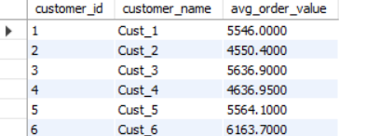

48.Find top 5 customers using HAVING.
SQL->
SELECT customer_id,customer_name,SUM(net_revenue) AS total_revenue FROM sales_cleanedGROUP BY customer_id, customer_name ORDER BY total_revenue DESC
FETCH FIRST 5 ROWS ONLY;

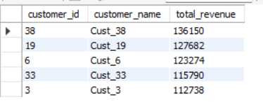

49.Stores with max transactions.
SQL->
Select store_type , count(sale_id)as transactions from sales_cleaned group by store_name having count(sale_id) = (select max(cnt) from(select count(*) as total_transactions from sales_cleaned group by store_name)t);

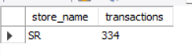

50.Categories with high growth.
SQL->
Select category , sum(net_amount) as total_revenue from sales_cleaned group by category having total_revenue > 80000
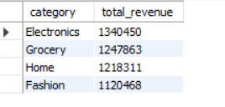
CASE WHEN
Manager Requirement:
Segment customers for business decisions.
Questions:

51.Classify customers as High/Medium/Low spenders.
SQL->
Select customer_id, customer_name ,sum(net_amount) as total_spent,
Case
WHEN total_spent > 20000 THEN 'High'
WHEN total_spent > 10000 THEN 'Medium'
ELSE ‘Low’
End as spender_type
From sales_cleaned group by customer_id,customer_name

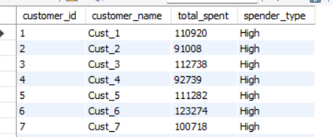

52.Classify transactions as Big/Small.
SQL->
Select sale_id , net_revenue
Case
When net_revenue > 5000 then ‘Big’
Else ‘Small’
End as transaction_size
From sales_cleaned

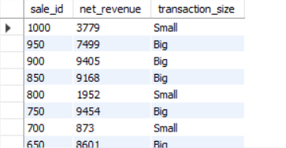

53.Create discount flag.
SQL->

Select sale_id,discount
Case
When discount>0 then ‘Discount Applied’
Else ‘No Discount’
End as discount_flag
From sales_cleaned

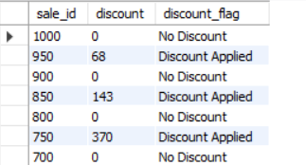

54.Segment stores based on revenue.
SQL->

Select store_name, sum(net_amount) as total_revenue
Case
When total_revenue > 100000 then ‘Top Store’
Else ‘Regular Store’
End as store_segment
From sales_cleaned

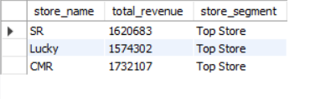

55.Categorize customers based on frequency.
SQL->

SELECT customer_id,customer_name,COUNT(*) AS total_orders,
CASE
WHEN COUNT(*) > 10 THEN 'Frequent'
WHEN COUNT(*) > 5 THEN 'Occasional'
ELSE 'Rare'
END AS frequency_type
FROM sales_cleaned GROUP BY customer_id, customer_name;

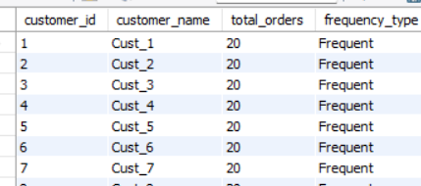

56.Create sales buckets.
SQL->
Select sale_id, net_revenue
Case
When net_revenue <1000 then ‘Low’
When net_revenue between 1000 and 5000 then ‘Medium’
Else ‘High’
End as sales_bucket
From sales_cleaned

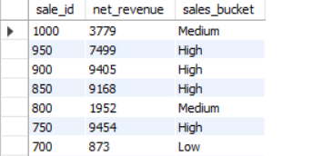

57.Identify premium customers.
SQL->

Seledct customer_id, customer_name, sum(net_revenue) as total_spent
Case
When total_spent > 30000 THEN 'Premium'
ELSE 'Regular'
END AS customer_type
FROM sales_cleaned
GROUP BY customer_id, customer_name;

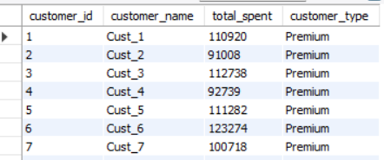

58.Mark high-value transactions.
SQL->

SELECT
sale_id,
net_revenue,
CASE
WHEN net_revenue > 7000 THEN 'High Value'
ELSE 'Normal'
END AS value_flag
FROM sales_cleaned;

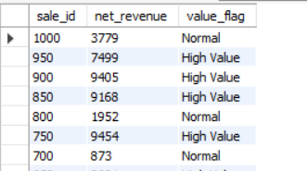
59.Classify categories based on performance.
SQL->

SELECT
category,
SUM(net_revenue) AS total_revenue,
CASE
WHEN SUM(net_revenue) > 80000 THEN 'High Performing'
ELSE 'Low Performing'
END AS performance_type
FROM sales_cleaned
GROUP BY category;

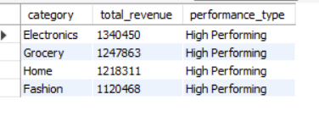

60.Create custom labels for reporting.
SQL->

SELECT
sale_id,
store_name,
category,
net_revenue,
CASE
WHEN net_revenue > 5000 AND discount = 0 THEN 'High Value NoDiscount'
WHEN net_revenue > 5000 THEN 'High Value Discounted'
ELSE 'Regular Sale'
END AS report_label
FROM sales_cleaned;

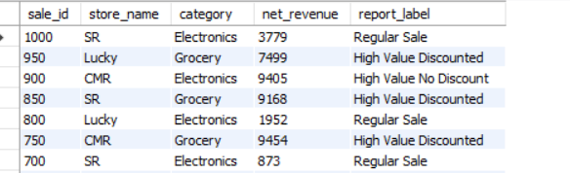

JOINS

Manager Requirement:
Combine customer, product, and store data for insights.
Questions:
61.Join sales with customers table.
SQL->
SELECT
s.sale_id,
c.customer_name,
s.amount
FROM sales s
JOIN customers c
ON s.customer_id = c.customer_id;

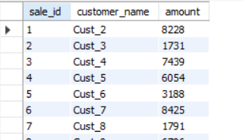

62.Join sales with stores table.
SQL->
SELECT
s.sale_id,
st.store_name,
s.amount
FROM sales s
JOIN stores st
ON s.store_id = st.store_id;

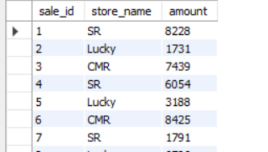

63.Join sales with products table.
SQL->
SELECT
s.sale_id,
p.category,
s.amount
FROM sales s
JOIN products p
ON s.product_id = p.product_id;

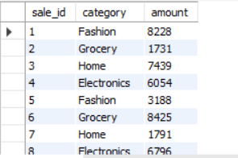

64.Find customer name with store name and sales.
SQL->
SELECT
c.customer_name,
st.store_name,
s.amount
FROM sales s
JOIN customers c ON s.customer_id = c.customer_id
JOIN stores st ON s.store_id = st.store_id;

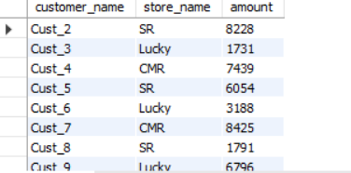

65.Find category-wise revenue using joins.
SQL->

SELECT
p.category,
SUM(s.amount) AS total_revenue
FROM sales s
JOIN products p ON s.product_id = p.product_id
GROUP BY p.category;

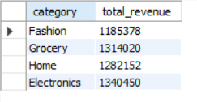

66.Find store-wise customer count.
SQL->

SELECT
st.store_name,
COUNT(DISTINCT s.customer_id) AS customer_count
FROM sales s
JOIN stores st ON s.store_id = st.store_id
GROUP BY st.store_name;

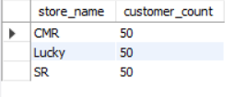

67.Find top product per store.
SQL->

SELECT *
FROM (
SELECT
st.store_name,
p.category,
SUM(s.amount) AS total_sales,
ROW_NUMBER() OVER (
PARTITION BY st.store_name
ORDER BY SUM(s.amount) DESC) AS rn
FROM sales s
JOIN stores st ON s.store_id = st.store_id
JOIN products p ON s.product_id = p.product_id
GROUP BY st.store_name, p.category
)
WHERE rn = 1;

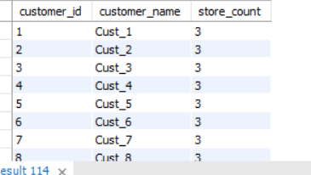

68.Find customers who purchased from multiple stores.
SQL->
SELECT
c.customer_id,
c.customer_name,
COUNT(DISTINCT s.store_id) AS store_count
FROM sales s
JOIN customers c ON s.customer_id = c.customer_id
GROUP BY c.customer_id, c.customer_name
HAVING COUNT(DISTINCT s.store_id) > 1;

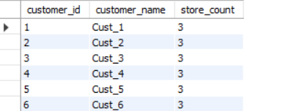

69.Find sales with product category.
SQL->

SELECT
s.sale_id,
p.category,
s.amount
FROM sales s
JOIN products p ON s.product_id = p.product_id;

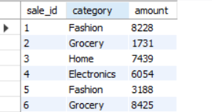

70.Find revenue per customer per store.
SQL->

SELECT
c.customer_name,
st.store_name,
SUM(s.amount) AS total_revenue
FROM sales s
JOIN customers c ON s.customer_id = c.customer_id
JOIN stores st ON s.store_id = st.store_id
GROUP BY c.customer_name, st.store_name;

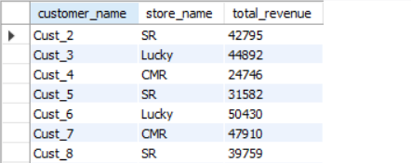

71.Find customers with no transactions (LEFT JOIN).
SQL->

SELECT
c.customer_id,
c.customer_name
FROM customers c
LEFT JOIN sales s
ON c.customer_id = s.customer_id
WHERE s.sale_id IS NULL;

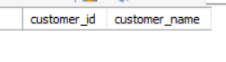

72.Find missing product mappings.
SQL->

SELECT
s.sale_id,
s.product_id
FROM sales s
LEFT JOIN products p
ON s.product_id = p.product_id
WHERE p.product_id IS NULL;

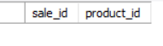

73.Find store performance using joins.
SQL->

SELECT
st.store_name,
SUM(s.amount) AS total_revenue,
COUNT(*) AS total_transactions
FROM sales s
JOIN stores st ON s.store_id = st.store_id
GROUP BY st.store_name;

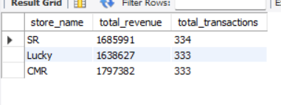

74.Find cross-category purchases.
SQL->

SELECT
c.customer_id,
c.customer_name,
COUNT(DISTINCT p.category) AS category_count
FROM sales s
JOIN customers c ON s.customer_id = c.customer_id
JOIN products p ON s.product_id = p.product_id
GROUP BY c.customer_id, c.customer_name
HAVING COUNT(DISTINCT p.category) > 1;

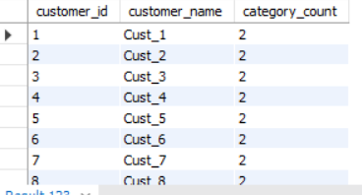

75.Find total revenue using joins.
SQL->

SELECT
SUM(s.amount) AS total_revenue
FROM sales s
JOIN products p ON s.product_id = p.product_id;

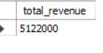

WINDOW FUNCTIONS

Manager Requirement:
Provide advanced analytics without losing row-level data.
Questions:
76.Calculate total spend per customer using window function.
SQL->
SELECT
sale_id,
customer_id,
net_revenue,
SUM(net_revenue) OVER (PARTITION BY customer_id) AS total_spend
FROM sales_cleaned;

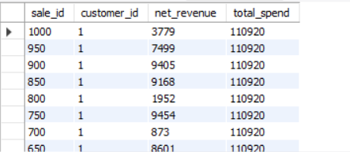

77.Rank customers by revenue.
SQL->
SELECT
customer_id,
total_revenue,
RANK() OVER (ORDER BY total_revenue DESC) AS rnk
FROM (
SELECT customer_id, SUM(net_revenue) AS total_revenue
FROM sales_cleaned
GROUP BY customer_id
);

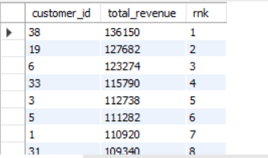

78.Find top customer per store.
SQL->
SELECT *
FROM (
SELECT
store_name,
customer_id,
SUM(net_revenue) AS total_spent,
RANK() OVER (
PARTITION BY store_name
ORDER BY SUM(net_revenue) DESC
) AS rnk
FROM sales_cleaned
GROUP BY store_name, customer_id
)
WHERE rnk = 1;

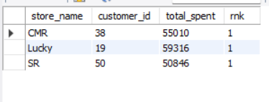

79.Calculate running total of sales.
SQL->
SELECT
sale_date,
net_revenue,
SUM(net_revenue) OVER (
ORDER BY sale_date
ROWS BETWEEN UNBOUNDED PRECEDING AND CURRENT ROW
) AS running_total
FROM sales_cleaned;

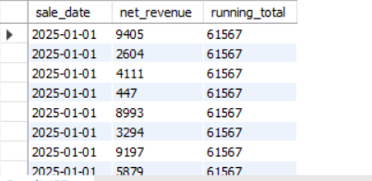

80.Find previous sale using LAG.
SQL->
SELECT
sale_id,
sale_date,
net_revenue,
LAG(net_revenue) OVER (ORDER BY sale_date) AS prev_sale
FROM sales_cleaned;

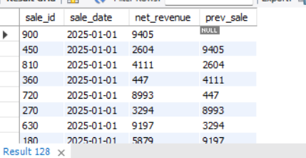

81.Find next sale using LEAD.
SQL->
SELECT
sale_id,
sale_date,
net_revenue,
LEAD(net_revenue) OVER (ORDER BY sale_date) AS next_sale
FROM sales_cleaned;

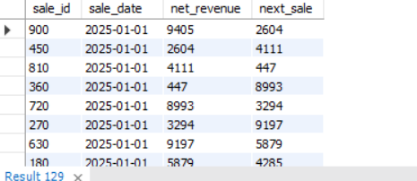

82.Calculate sales growth.
SQL->
SELECT
sale_id,
sale_date,
net_revenue,
net_revenue - NVL(LAG(net_revenue) OVER (ORDER BY sale_date),0) AS growth
FROM sales_cleaned;

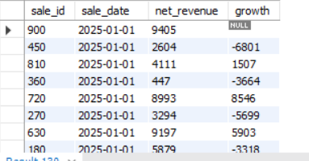

83.Find difference between transactions.
SQL->
SELECT
sale_id,
net_revenue,
net_revenue - LAG(net_revenue) OVER (ORDER BY sale_id) AS diff
FROM sales_cleaned;
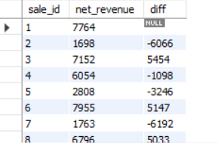

84.Calculate cumulative revenue.
SQL->
SELECT
sale_id,
net_revenue,
SUM(net_revenue) OVER (
ORDER BY sale_id
ROWS BETWEEN UNBOUNDED PRECEDING AND CURRENT ROW
) AS cumulative_revenue
FROM sales_cleaned;

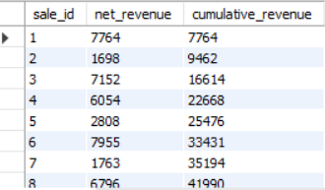

85.Find moving average of sales.
SQL->

SELECT
sale_id,
net_revenue,
AVG(net_revenue) OVER (
ORDER BY sale_id
ROWS BETWEEN 2 PRECEDING AND CURRENT ROW
) AS moving_avg
FROM sales_cleaned;

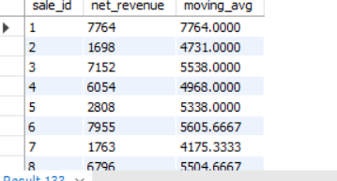

86.Rank stores by revenue.
SQL->
SELECT
store_name,
total_revenue,
RANK() OVER (ORDER BY total_revenue DESC) AS rnk
FROM (
SELECT store_name, SUM(net_revenue) AS total_revenue
FROM sales_cleaned
GROUP BY store_name
);

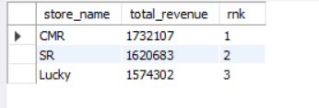

87.Find second highest sale.
SQL->
SELECT *
FROM (
SELECT
sale_id,
net_revenue,
DENSE_RANK() OVER (ORDER BY net_revenue DESC) AS rnk
FROM sales_cleaned
)
WHERE rnk = 2;

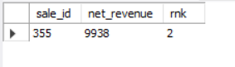
88.Partition data by store and analyze.
SQL->SELECT
store_name,
sale_id,
net_revenue,
SUM(net_revenue) OVER (PARTITION BY store_name) AS store_total
FROM sales_cleaned;

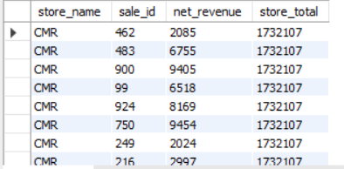
89.Find customer ranking per store.
SQL->
SELECT
store_name,
customer_id,
total_spent,
RANK() OVER (
PARTITION BY store_name
ORDER BY total_spent DESC
) AS rnk
FROM (
SELECT
store_name,
customer_id,
SUM(net_revenue) AS total_spent
FROM sales_cleaned
GROUP BY store_name, customer_id
);
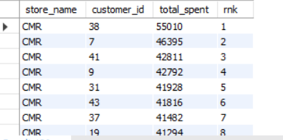

90.Calculate frequency using window.
SQL->
SELECT
customer_id,
COUNT(*) OVER (PARTITION BY customer_id) AS transaction_count
FROM sales_cleaned;

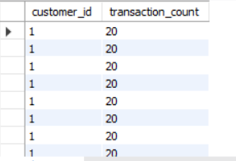

NTILE
Manager Requirement:
Segment customers for marketing.
91.Divide customers into 4 segments.
SELECT customer_id,total_spent,
NTILE(4) OVER (ORDER BY total_spent DESC) AS segment
FROM (
SELECT customer_id,SUM(amount) AS total_spent
FROM sales
GROUP BY customer_id
) t

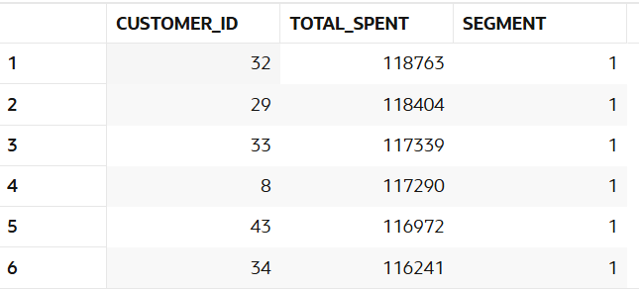

92. Identify top 25% customers.
SELECT * FROM (
SELECT customer_id,SUM(amount) AS total_spent,
NTILE(4) OVER (ORDER BY SUM(amount) DESC) AS quartile
FROM sales
GROUP BY customer_id
) t
WHERE quartile = 1

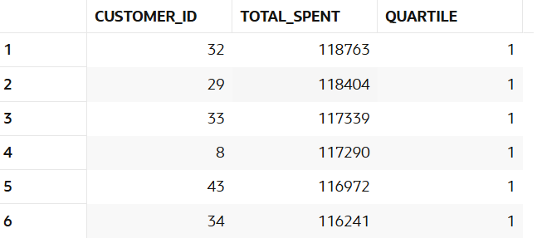

93. Identify bottom 25% customers.
SELECT * FROM (
SELECT customer_id,SUM(amount) AS total_spent,
NTILE(4) OVER (ORDER BY SUM(amount) DESC) AS quartile
FROM sales
GROUP BY customer_id
) t
WHERE quartile = 4

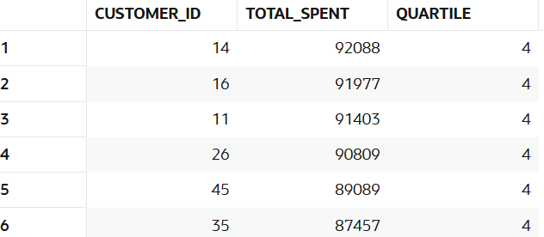

94.Segment stores into 3 groups.
SELECT store_id,total_sales,
NTILE(3) OVER (ORDER BY total_sales DESC) AS store_segment
FROM (
SELECT store_id,SUM(amount) AS total_sales
FROM sales
GROUP BY store_id
) t

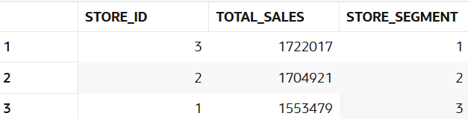

95.Create quartiles based on revenue.
SELECT customer_id,total_spent,
NTILE(4) OVER (ORDER BY total_spent DESC) AS quartile
FROM (
SELECT customer_id, SUM(amount) AS total_spent
FROM sales
GROUP BY customer_id
) t

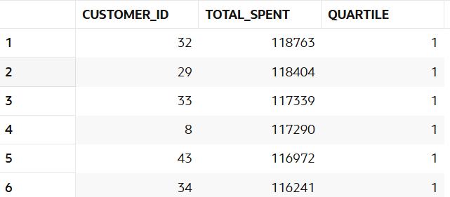

96.Segment customers per store.
SQL->
SELECT customer_id,store_id,total_spent,
NTILE(3) OVER (PARTITION BY store_id ORDER BY total_spent DESC) AS segment
FROM (
SELECT customer_id,store_id,SUM(amount) AS total_spent
FROM sales
GROUP BY customer_id, store_id
) t

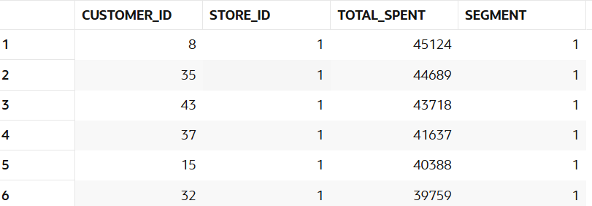

97.Identify premium segment.
SQL->
SELECT customer_id,SUM(amount) AS total_spent,
NTILE(4) OVER (ORDER BY SUM(amount) DESC) AS quartile,
CASE
WHEN NTILE(4) OVER (ORDER BY SUM(amount) DESC) = 1 THEN 'Premium'
WHEN NTILE(4) OVER (ORDER BY SUM(amount) DESC) = 2 THEN 'Gold'
WHEN NTILE(4) OVER (ORDER BY SUM(amount) DESC) = 3 THEN 'Silver'
ELSE 'Bronze'
END AS segment
FROM sales
GROUP BY customer_id
order BY customer_id

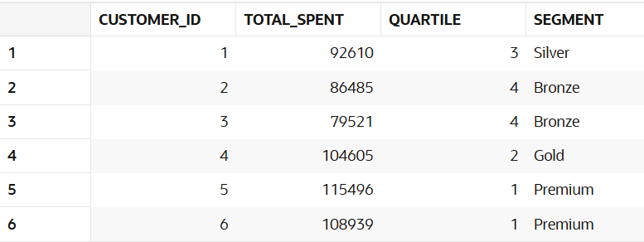

98. Find mid-level customers.
SQL->
SELECT *FROM (
SELECT customer_id,SUM(amount) AS total_spent,
NTILE(4) OVER (ORDER BY SUM(amount) DESC) AS quartile
FROM sales
GROUP BY customer_id
) t
WHERE quartile in (2,3)
order by customer_id

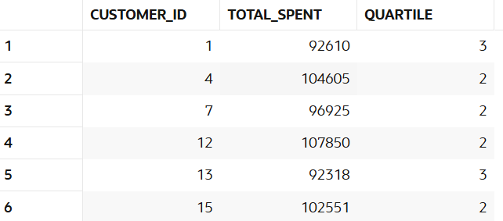

99.Analyze bucket distribution.
SELECT quartile,COUNT(*) AS customer_count
FROM (
SELECT customer_id,
NTILE(4) OVER (ORDER BY SUM(amount) DESC) AS quartile
FROM sales
GROUP BY customer_id
) t
GROUP BY quartile

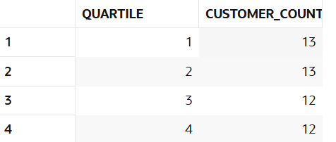

100. Create marketing segments.
SELECT customer_id,total_spent,
CASE
WHEN total_spent >= 100000 THEN 'VIP'
WHEN total_spent >= 50000 THEN 'Premium'
WHEN total_spent >= 10000 THEN 'Regular'
ELSE 'Low Value'
END AS marketing_segment
FROM (
SELECT customer_id,SUM(amount) AS total_spent
FROM sales
GROUP BY customer_id
) t
order by customer_id

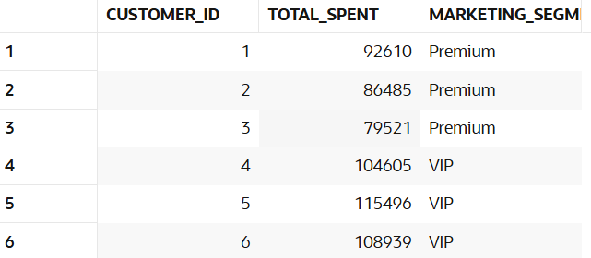

FIRST_VALUE/LAST_VALUE
Manager Requirement:
Compare performance with best and worst.
101.Find highest sale.
SELECT sale_id,amount,
FIRST_VALUE(amount) OVER (ORDER BY amount DESC) AS highest_sale
FROM sales

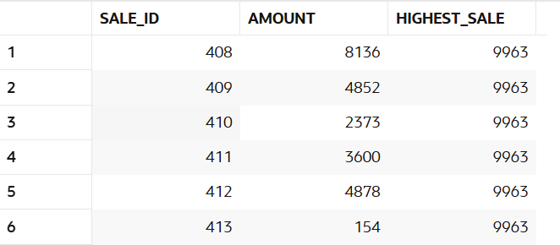

102.Find lowest sale.
SELECT sale_id,amount,
LAST_VALUE(amount) OVER (
ORDER BY amount DESC
ROWS BETWEEN UNBOUNDED PRECEDING AND UNBOUNDED FOLLOWING
) AS lowest_sale
FROM sales

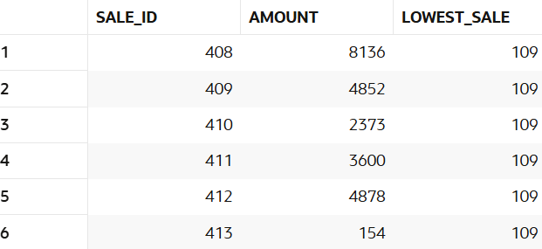

103.Compare each sale with highest.
SELECT sale_id,amount,
FIRST_VALUE(amount) OVER (ORDER BY amount DESC) - amount AS diff_from_highest
FROM sales
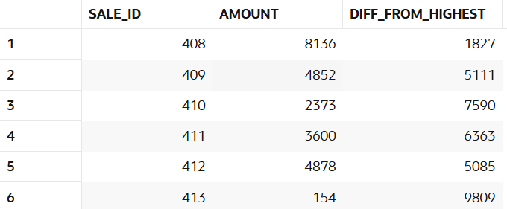

104.Compare each sale with lowest.
SELECT sale_id,amount,amount - LAST_VALUE(amount) OVER (
ORDER BY amount
ROWS BETWEEN UNBOUNDED PRECEDING AND UNBOUNDED FOLLOWING
) AS diff_from_lowest
FROM sales

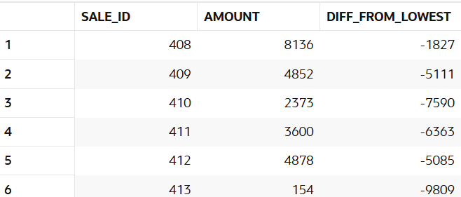

105.Find highest sale per store.
SELECT sale_id,store_id,amount,
FIRST_VALUE(amount) OVER (
PARTITION BY store_id
ORDER BY amount DESC
) AS highest_sale_store
FROM sales

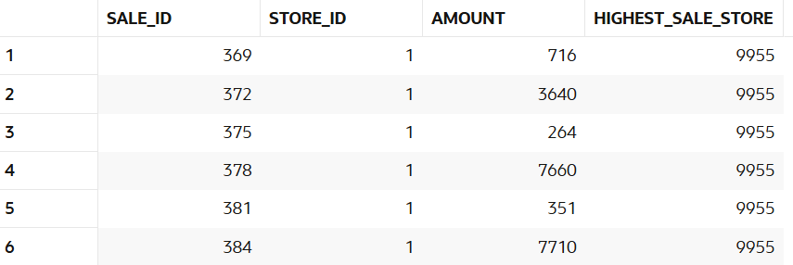

106.Find lowest sale per store.
SELECT sale_id,store_id,amount,
LAST_VALUE(amount) OVER (
PARTITION BY store_id
ORDER BY amount
ROWS BETWEEN UNBOUNDED PRECEDING AND UNBOUNDED FOLLOWING
) AS lowest_sale_per_store
FROM sales

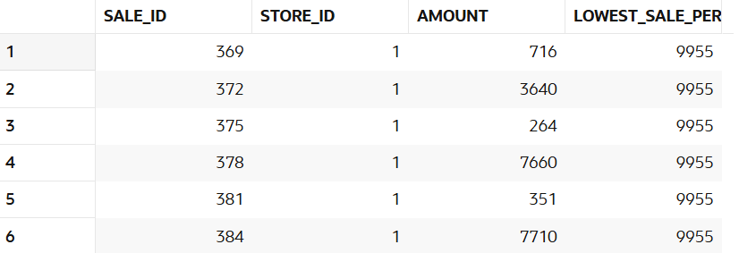

107. Compare category performance.
SELECT p.category,SUM(s.amount) AS total_revenue,
FIRST_VALUE(SUM(s.amount)) OVER (
ORDER BY SUM(s.amount) DESC
) AS highest_revenue
FROM sales s
JOIN products p
ON s.product_id = p.product_id
GROUP BY p.category

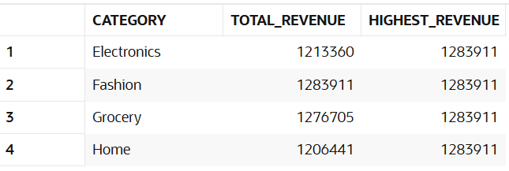

108.Find best customer per store.
WITH t AS (
SELECT store_id,customer_id,SUM(amount) AS total_spent,
RANK() OVER (
PARTITION BY store_id
ORDER BY SUM(amount) DESC
) AS rnk
FROM sales
GROUP BY store_id, customer_id
)
SELECT store_id,customer_id AS best_customer,total_spent
FROM t
WHERE rnk = 1

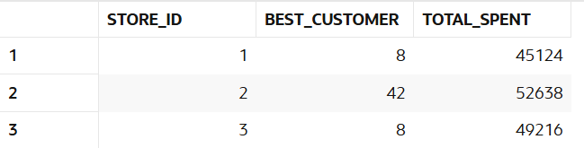

109.Find worst performing category.
SELECT p.category,SUM(s.amount) AS total_revenue
FROM sales s
JOIN products p
ON s.product_id = p.product_id
GROUP BY p.category
ORDER BY total_revenue
FETCH FIRST 1 ROW ONLY
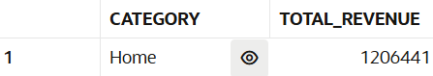

110.Analyze gap between best and worst.
WITH t AS (
SELECT p.category,SUM(s.amount) AS total_revenue
FROM sales s
JOIN products p
ON s.product_id = p.product_id
GROUP BY p.category
)
SELECT
MAX(total_revenue) AS best_revenue,
MIN(total_revenue) AS worst_revenue,
MAX(total_revenue) - MIN(total_revenue) AS gap
FROM t

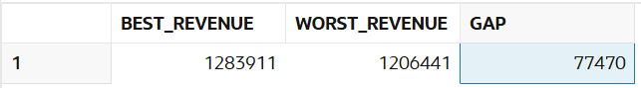

DATE ANALYSIS

Manager Requirement:
Analyze time-based trends.

111.Find daily sales.
select sale_date,sum(amount) as daily_sales from sales
group by sale_date
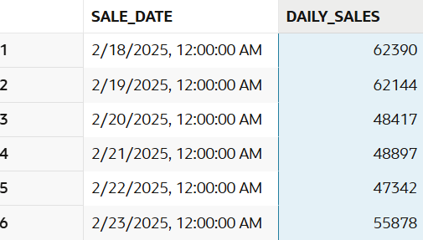

112.Find monthly sales.
SELECT TO_CHAR(sale_date, 'YYYY-MM') AS month,
SUM(amount) AS monthly_sales FROM sales
GROUP BY TO_CHAR(sale_date, 'YYYY-MM')
ORDER BY month

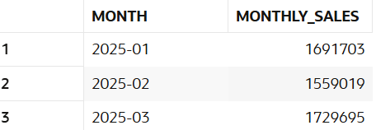

113.Find weekend sales.
select sale_date,sum(amount) as Weekend_sales from sales
where to_char(sale_date,'dy') in('sat','sun')
group by sale_date
order by sale_date

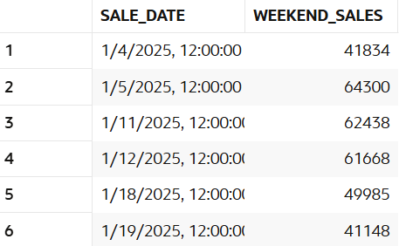

114.Find first sale date.
SELECT MIN(sale_date) AS first_sale
FROM sales

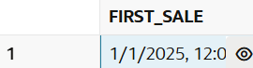

115.Find last sale date.
SELECT MAX(sale_date) AS last_sale
FROM sales

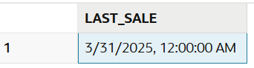

116.Find sales in specific month.
SELECT *
FROM sales
WHERE TO_CHAR(sale_date, 'YYYY-MM') = '2025-03'

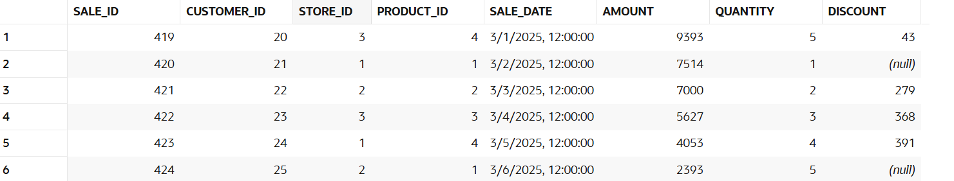

117.Find sales growth month-wise.
SELECT month,
total_sales,
total_sales - LAG(total_sales) OVER (ORDER BY month) AS growth
FROM (
SELECT TO_CHAR(sale_date, 'YYYY-MM') AS month,
SUM(amount) AS total_sales
FROM sales
GROUP BY TO_CHAR(sale_date, 'YYYY-MM')
)

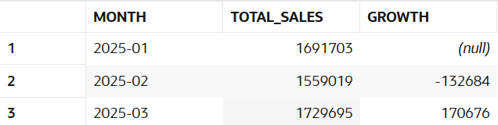

118.Find inactive customers (30 days).
SELECT customer_id
FROM customers
WHERE customer_id NOT IN (
SELECT customer_id
FROM sales
WHERE sale_date >= (
SELECT MAX(sale_date) FROM sales) - 30
)
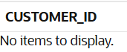

119. Find repeat customers.
SELECT customer_id,COUNT(*) AS orders
FROM sales
GROUP BY customer_id
HAVING COUNT(*) > 1
order by customer_id

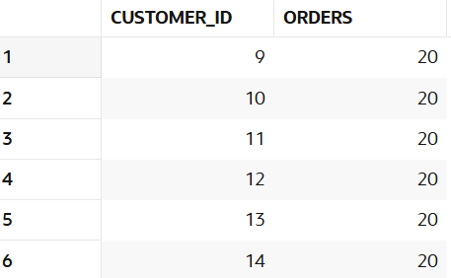

120.Find sales trend.
SELECT TO_CHAR(sale_date, 'YYYY-MM-DD') AS day,
SUM(amount) AS sales FROM sales
GROUP BY day
ORDER BY day

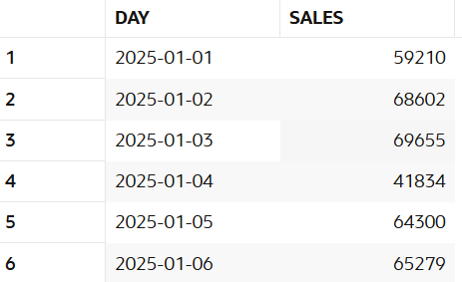

~SIRI

